**PCF**

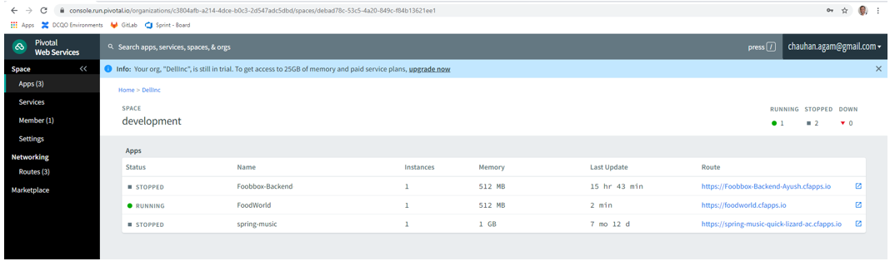

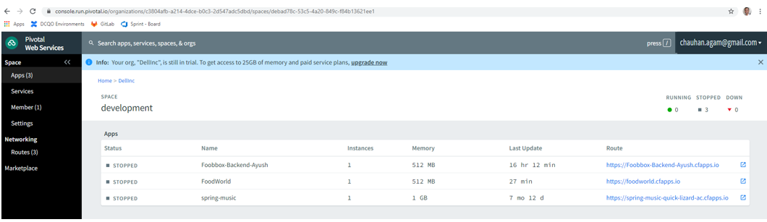

Steps to deploy to PCF

1. For the front end app, run the command “ng build --prod” in the terminal.
2. In the dist folder created, create a file with name as “manifest.yml”
3. Update the yml file content as below

applications:

- name: FoodBox

memory: 512M

disk_quota: 1024M

instances: 1

buildpack: staticfile_buildpack

domain: cfapps.io

1. Navigate to the project path in file explorer where manifest.yml is there and then open cmd prompt
2. Type the command “cf login” and enter the API endpoint and username and password
3. Enter command “cf push” and project should be successfully deloyed

Jenkins :

Install the maven package and cloud foundry

Click on New Item and enter a name

Select Maven Project

Go to SCM -> select Git and provide url

Add post build- > push to cloud foundry

Provide the details of cf

Build Now

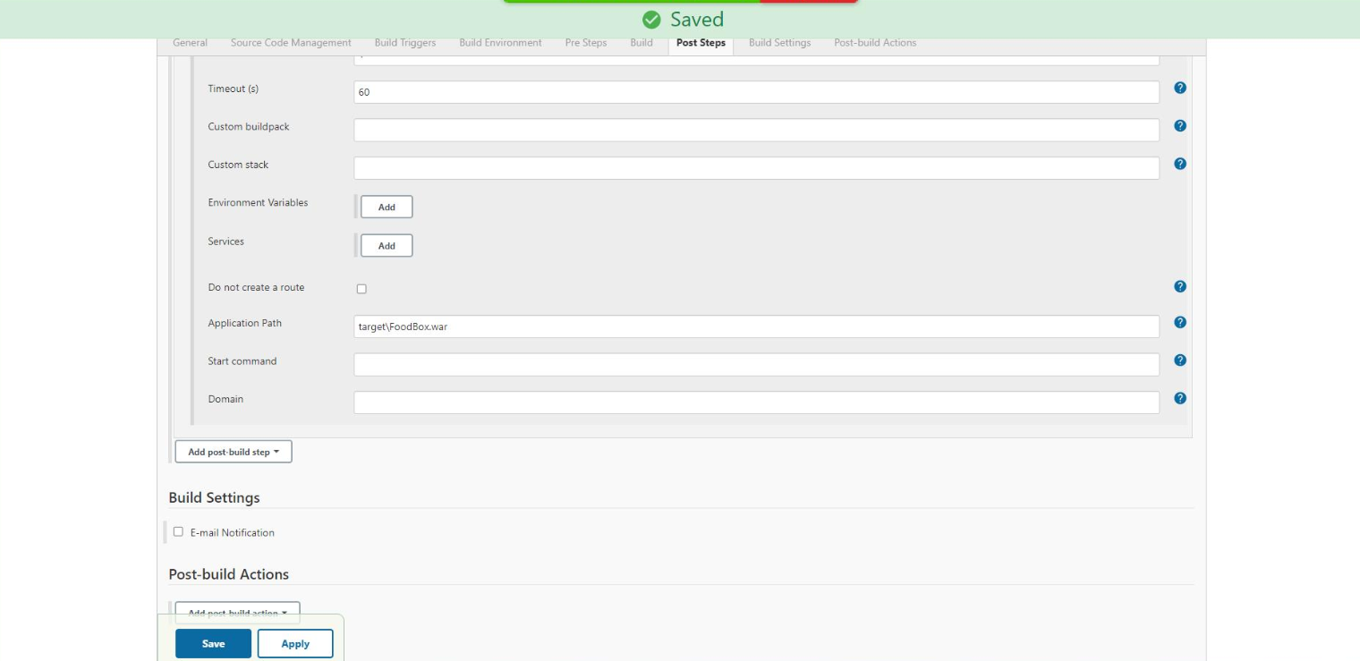

Build Success Logs

